ASSIGNMENT-13

WORD CLOUD

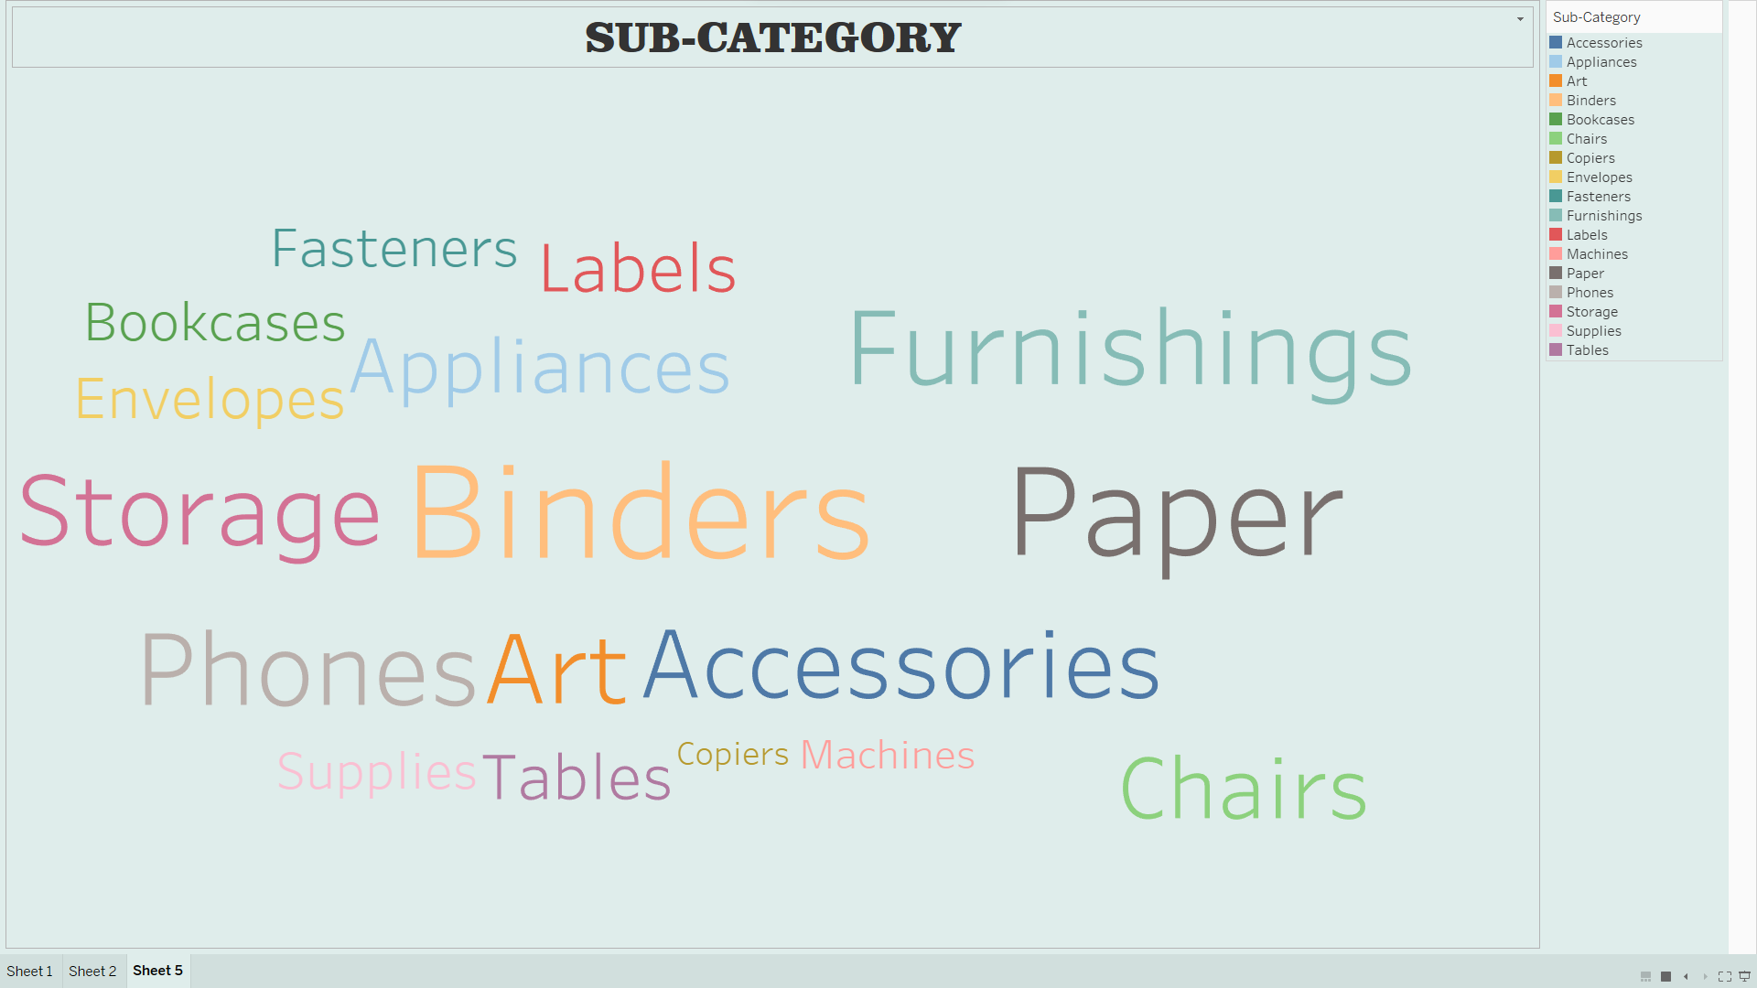

CONTROL CHART

